-- EXTRA1: Executar o mesmo reporte da questão 4 do curso (módulo 4) mas sem utilizar a view.

**SELECT** **Distinct**(department_name)

,SUM(salary_amount) **as** SomaDepartamento

**FROM** CustomerService.employee

**Inner** **Join** CustomerService.department

**On** employee.department_number = department.department_number

**Group** **By** 1

**Having** SUM(salary_amount) > 100000**;**

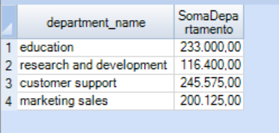

-- EXTRA2: Criar view que exibirá os 10 funcionarios mais "velhos de casa", mostrando nome completo, nome do departamento e tempo de casa em dias.

**CREATE** **VIEW** mais_velhoV **AS**

**SELECT** **top** 10

d.department_name

,e.first_name

,e.last_name

,(CURRENT_DATE - e.hire_date) / 365.25 **as** tempo_contratacao_dias

**FROM** customerService.employee e

**inner** **join** customerService.department d **on** (e.department_number = d.department_number)

**Order** **by** tempo_contratacao_dias **desc**

**;**

**SELECT** * **FROM** mais_velhoV**;**

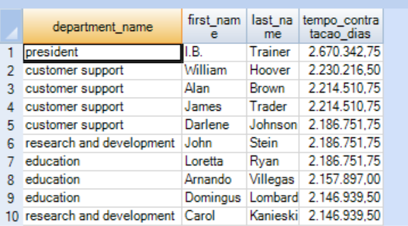

-- EXTRA3: Recriar a view anterior mas demonstrando o tempo de casa quebrado em anos, meses, dias.

**Replace** **VIEW** mais_velhoV **AS**

**SELECT** **top** 10

d.department_name

,e.first_name

,e.last_name

,(CURRENT_DATE - e.hire_date) **as** tempo_contratacao

,(CURRENT_DATE - e.hire_date) **as** tempo_contratacao_ano

,(CURRENT_DATE - e.hire_date) *12 **as** tempo_contratacao_mes

,(CURRENT_DATE - e.hire_date) * 365.25 **as** tempo_contratacao_dias

**FROM** customerService.employee e

**inner** **join** customerService.department d **on** (e.department_number = d.department_number)

**Order** **by** tempo_contratacao **desc**

**;**

**Replace** **VIEW** mais_velhoV **AS**

**select** **top** 10

first_name || ' ' || last_name

, department_name,hire_date

, (current_date - hire_date) / 365 **as** anos_casa

, (add_Months(date, - anos_casa * 12) - hire_date) / 30 **as** meses_casa

, (add_Months(date, - anos_casa * 12) - hire_date) mod 30 **as** dias_casa

**from** CustomerService.employee e

, CustomerService.department d

**where** d.department_number = e.department_number

**order** **by** anos_casa **desc**, meses_casa **desc**, dias_casa **desc;**

**;**

**select** * **from** mais_velhoV.

